Test Plan

Bowlstrike.py

*Name: Vitor Antunes Cazella*

*Student ID: 91050051*

# The Product

The project is developing a 10 pin bowling game prototype that can be used to teach a variety of subjects, it is made by a company specialised in educational software.

**Rules of Play**

Each game of bowling has ten frames. In each frame, the bowler will have two chances to knock down as many pins as possible with their bowling ball. When the game has more than one bowler, as is common, every bowler will take their frame in a predetermined order before the next frame begins. If a bowler knocks down all ten pins with their first ball, he is awarded a strike. If the bowler knocks down all 10 pins with the two balls of a frame, it is known as a spare. Bonus points are awarded for both a strike and a spare. Bonus points are to be awarded depending on what is scored in the next 2 balls (for a strike) or 1 ball (for a spare). If the bowler knocks down all 10 pins in the tenth frame, the bowler is allowed to throw 3 balls for that frame. This allows for a potential of 12 strikes in a single game, and a maximum score of 300 points, a perfect game.

# Test Strategy

## Testing Scope

In Scope:

* Code formatting
* Functions
* Prototype

Out of Scope:

* Graphic UI
* Database
* Input data

## Testing Type

Focused Testing Types:

* Back-end Testing
* Component Testing
* Functional Testing

Testing Types should be ignored:

* Graphical User Interface Testing
* Compatibility Testing
* Performance Testing

## Test Logistics

Testing and Bug fixing are going to be performed by Vitor Cazella, during the period of a week.

# Testing Objective

List of software features which may need to test.

* Record throws
* Number of pins
* Calculate score
* Spare scoring
* Strike scoring

Target of testing:

* Find errors that prevent code from running
  + Syntax
  + Formatting
  + Missing information

# Test Criteria

**Suspension Criteria**

If 40% of test cases failed during testing, you should suspend testing until the development team fixes all the failed cases.

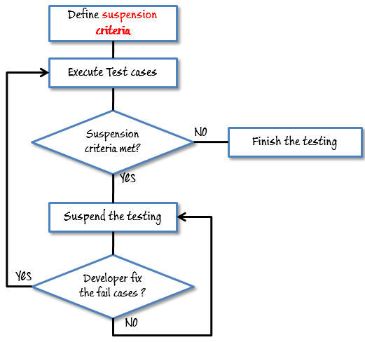

**Exit Criteria**

If tests reports 85% are successfully completed, testing can be finished.

# Resource Planning

Human resource

|  |  |  |
| --- | --- | --- |
| No. | Member | Tasks |
| 1. | Tester | Execute the tests, Log results, Report the defects. |
| 2. | Developer | Implement the test cases, test program, test suite etc. |

System Resource

|  |  |  |
| --- | --- | --- |
| No. | Resources | Descriptions |
| 1. | Test tool | Testing will be automated through functions in the code, using debugging from VS Code Python |
| 2. | Personal Computer | Machine that matches the users |

# Test Environment

Tests are going to be conducted in the following system:

* Windows 10 Home (Version 20H2)
* 64-bit operating system, x64-based processor
* Intel® Core™ i5-9400F CPU @ 2.90GHz
* 16 GB RAM

Used software:

* Visual Studio Code (Version 1.51.1)
* Python 3.8.6 64-bit

# Schedule

|  |  |
| --- | --- |
| Tasks | Expected Times |
| Creating test specification | 170 hour |
| Perform Test Execution | 80 hour |
| Test Report | 10 hour |
| Delivery Testing | 20 hour |
| Total | 280 hour |